1. Create a zero byte file(Name it as sample)

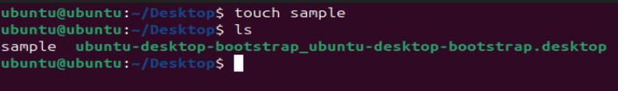

1. Create a directory.

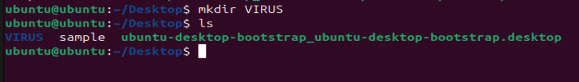

1. Create a directory(abc),inside abc create directory(z),inside Z create another directory(y).

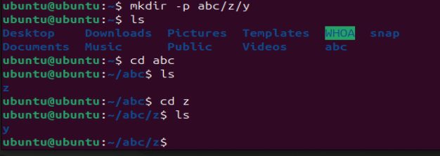

1. echo "hello world" and store that in sample file which we created at task1.

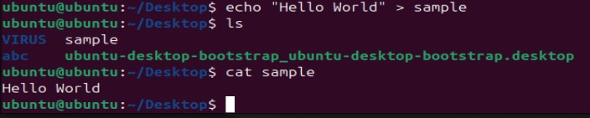

1. give permissions to "sample" file(owner-read and write,user-execute,other,read,write and execute permission)

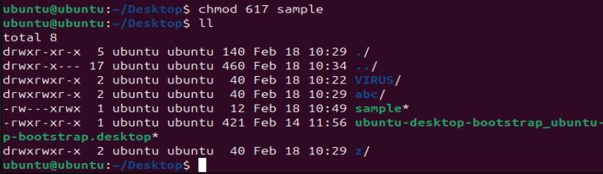

1. create a bash script file in "Z" directory created in task3.(Name of script: myscript.sh) Sample script: #!/bin/bash

echo "my path cd abc/a/b/c"

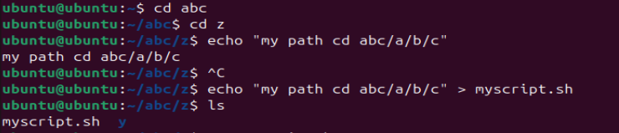



1. give full permissions myscript.sh

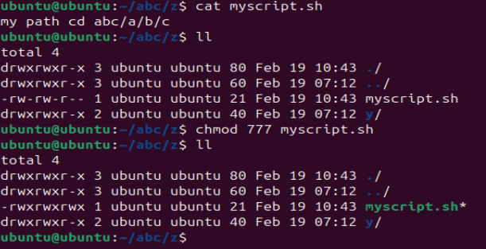

1. create a soft link to myscript.sh

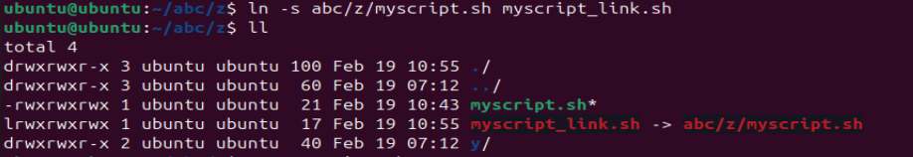

1. find the file "sample" and capture the output in same file.

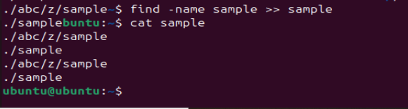

10)create a file"alphabet" and enter a,b,c,d,e,f,g,a,b and save the file.

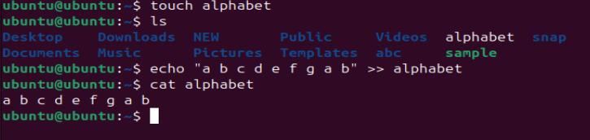

1. grep the keyword small a in file alphabet.



12) grep the keyword capital A in file alphabet.



13).create a script name "demo.sh". Sample script: #!/bin/bash echo "my demo" sleeep "60"

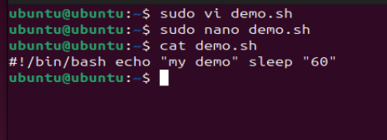

14) open one gitbash terminal and check for demo.sh process.

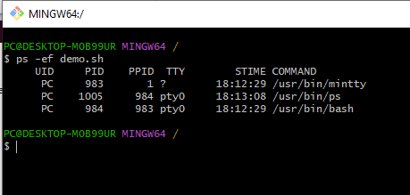

15) rerun the demo.sh terminal and kill the process from anaother gitbash terminal.

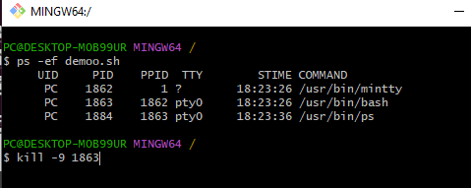

16) check the user id of pc.

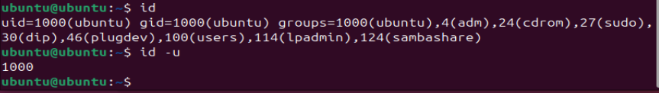

17) check the username of pc.



18) check the operating system of pc.

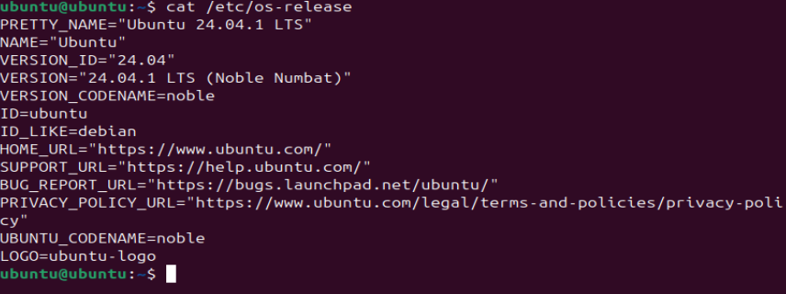

19) check the free space available of pc.

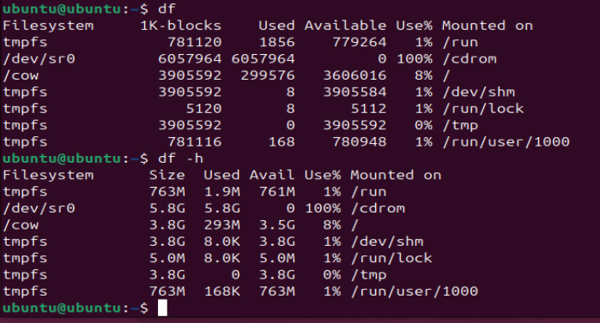

20) check the cpu utilization of pc.

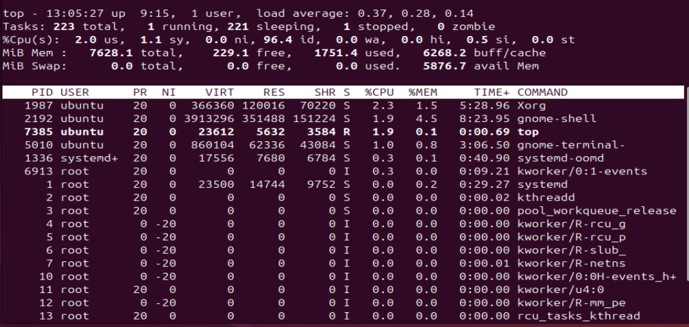

21) create a directory with any name and tar that directory.

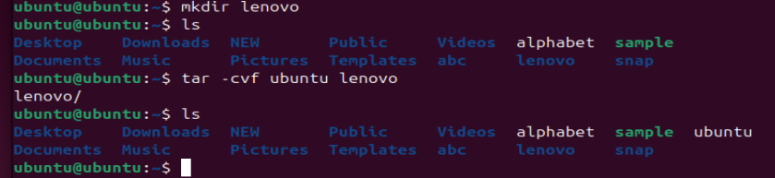

22) now remove the directory and untar the tar file created in step 30.

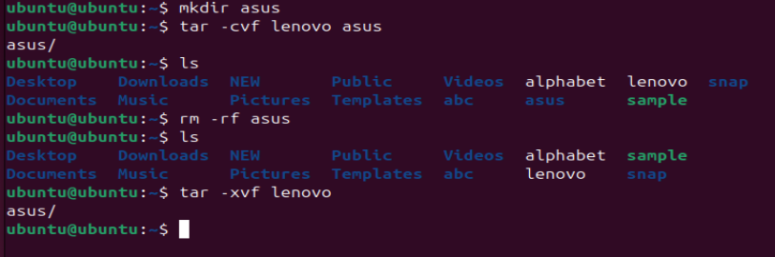

33) Execute the below command. history >> mytask

